**Information**

1. The database is designed to open in a read only view to allow people to search for individuals without risk of editing the data.
2. When you put the database on a new machine, the first time you try to open it you may get an error. On the error message click “Stop all macros”

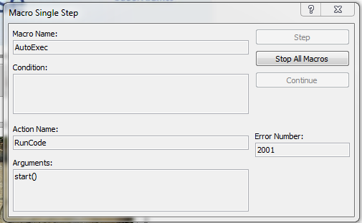

Then click to “Enable Content”



In the future, you will not need to do this as the database will be trusted on that computer.

1. To open the database in editable format you must hold down the “Shift” key and then double click on the database holding the “Shift” key until it opens. This will display all the tables and forms available to use and/or edit. This should only be used by individuals familiar with MS Access.

**List of Database Objects**

Tables

* GraveData – this is the only table and contains all information regarding the individuals in the cemetery. Custom queries can be written against this to create reports.

Queries

* Q_DistinctPlots – this query selects all the distinct grave locations since it is used to select the physical location on the map.

Forms

* CemetaryMap – this form contains the high-resolution Aerial photo of the cemetery with all the measured grave locations plotted on it.
* MainForm – this is the form that is read only and is displayed by default on opening the database in normal (non-editable) mode. It allows for searching, filtering and launching the map highlighting the desired location.
* MainForm-edit – this is a copy of the MainForm with the fields set to allow editing. Be careful using this as the edits are automatically reflected in the table and they cannot be undone!
* Search – the form that allows the users to perform searches.

Macros

* autoExec – executes at database startup to hide all the menu options to prevent the user from accessing database objects or menu items. Essentially makes sure the users cannot mess up the data.

Modules

* Module1 – contains some visual basic computer code to allow the database to perform advanced searches, filters and display the physical grave locations on the map.